**Project Design Phase-II**

**Data Flow Diagram & User Stories**

|  |  |
| --- | --- |
| Date | 15 October 2022 |
| Team ID | PNT2022TMID44635 |
| Project Name | Project – analytics of hospital health care data |

**Data Flow Diagrams**

**:** 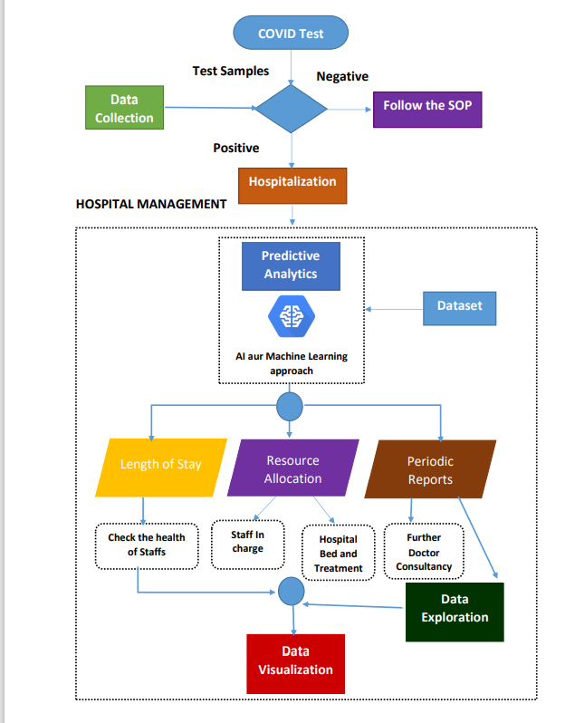

**Example:** [**(Simplified)**](https://developer.ibm.com/patterns/visualize-unstructured-text/)

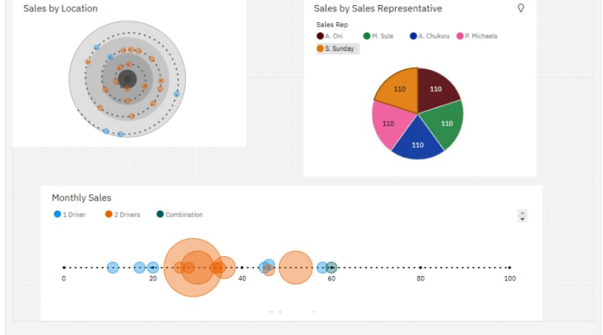

**User Stories**

Use the below template to list all the user stories for the product.

|  |  |  |  |  |  |
| --- | --- | --- | --- | --- | --- |
| **User Type** | **Functional**  **Requirement (Epic)** | **User**  **Story**  **Number** | **User Story / Task** | **Acceptance criteria** | **Priority** |
| patients | hospitalization | USN-1 | Patients are required hospitalized if  they have covid positive | Maintain the Record for correct preference.  Direct hospitalization | High |
|  | Treatment report | USN-2 | Patients should collect their treatment report  and get the doctor consult | They can receive the report form hospital.  For Admission purpose of patient to get solutions among their problem | High |
| Hospital management | **Resource allocation** | **USN 3** | Hospital management should be allocate the necessary resource for treating the covid patients | Should be ready for any circumstance | High |
|  | Predicting | USN-4 | The doctors should be aware of condition of patient the predict | Exploring the data about the patient health condition and predicting | High |
|  | Resource availability | USN-5 | As a user, I access the data in visualize | Visualize the about the resource availability | High |
|  | Dashboard | USN-6 | As a user, I can access the data from queries, graph, pie chart |  | High |
| Customer Care Executive |  |  | Have data in graph modes |  |  |
| Customer (Web user) |  |  | Get the older information from the hospitals |  |  |
|  |  |  |  |  |  |